A Review Paper on:Study on Organic Light-Emitting Diode(OLED) With Advantages And Disadvantages

Authors Name: Pooja S Harugop
Computer Science Department, KLS GIT, Belagavi
Belagavi, INDIA
E-mail: poojaharugop@gmail.com
Co-Authors Name: Papanna B Belavi
Physics Department, KLS GIT, Belagavi
Belagavi, INDIA
E-mail: pbbelavi@git.edu

Abstract— An Organic Light Emitting Diode (OLED) is a semiconductor device, solid in state containing a conducting and an emissive layer between two electrodes in which the emissive electroluminescent layer is a film of to create light with application of electricity. This layer of organic semiconductor is situated between two electrodes; typically at least one of these electrodes is transparent. Used in many day-to-day appliances such as portable mobile phones, handheld games, digital displays in television screens, computer monitors etc.
Keywords: AMOLED, LED, OLED, PMOLED.

Introduction
An OLED is a thin-film device in a solid state which has replaced CRTs and LCDs in the last few decades. The emission of light from materials in an electric field is called as Electroluminescence [1]. There are two main families of OLED those based on small molecules and those employing polymers. By adding mobile ions to an OLED we get a light emitting electrochemical cell (LEC) [2]. An OLED display can be operated with a passive matrix (PMOLED) or active matrix (AMOLED). An OLED display works without a backlight. An OLED has many advantages over LCD, as LCD gives a thicker and dark backlights because its uses cold cathode fluorescent lamps [3]. The concept of hole or electron limited electroluminescence in OLEDs decrease the operating voltage when improving the light output and efficiency. Electroluminescence in organic materials was first observed in 1950 by Andre Bernanos at the Nancy University in France, by applying high voltages in air to acridine orange. Ohmic dark-injecting electrode was developed by Martin Pope in NY University in 1960. They explained needs for hole and electron electrode contacts. DC electroluminescence was first observed under vacuum on one crystal of anthracene by Pope‘s group. He implied in 1965 that when external E.F. is absent, electroluminescence in anthracene crystals is generated by recombination of electron and hole. Double injection recombination electroluminescence was produced in an anthracene crystal through hole and electron electrodes by W. Helfrich and W. G. Schneider of the National Research Council in Canada in 1965. They reported about electronic excitation at contacts between graphite molecules and anthracene particles. Electro luminescence of polymer films was observed by Roger Partridge at the National Physics Laboratory in the UK. It had a film of poly(n-vinyl carbazole) between two charged injecting electrodes. The first practical OLED’s was prepared by an American physical chemist Ching W. Tang and Steven Van Slyke at Eastman Kodak in 1987[2]. At start they used a two layered structure with separate hole transporting and electron transporting layers such that recombination and light emission occurred in the middle of the organic layer, this resulted in a reduction in operating voltage and improvements in efficiency. An OLED is a solid state semiconductor device, whose thickness is about 100-500mm and consists of a conducting layer and an emissive layer between two electrodes and placed on a substrate. Basically OLEDs are double charge injection devices, which require continuous supply of electrons and holes to the electroluminescent material between the electrons. In the two layers based OLED, electrons injected from the cathode in LUMO (conduction band) and holes are injected from the anode in HOMO (valence band). In three layers based OLED, the conductive layer is replaced by electron–transport layer (ETL) and hole-transport layer (HTL). 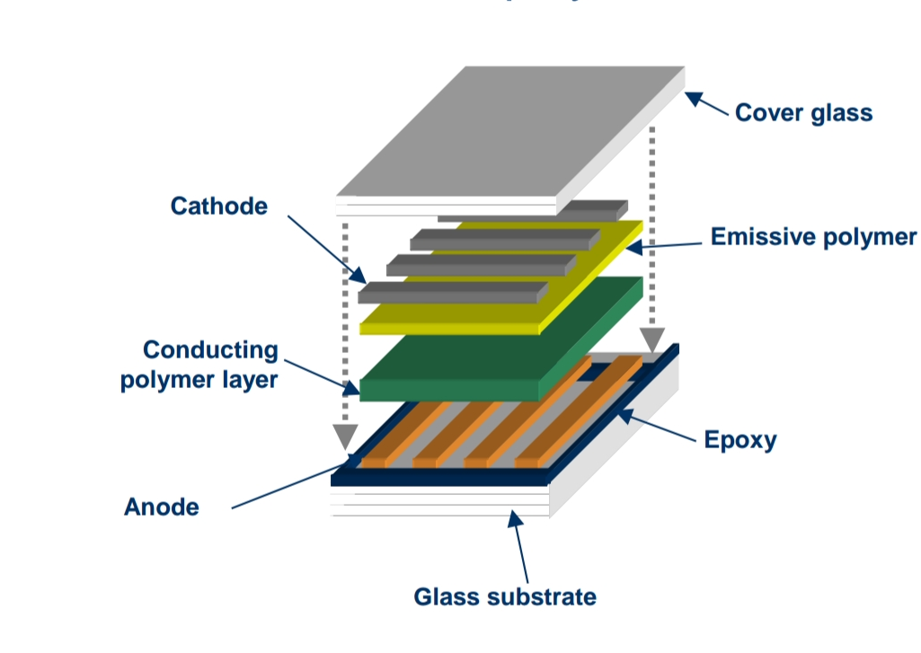

discussion
OLED are nothing but monolithic semi-conductor device, with a then film and is in solid state, which emits light when voltage is passed to it. Normally when electric field is applied to organic materials, various lights are generated. This is known as EL (electroluminescence).
Material Structure: OLED has a series of vacuum deposited, organic thin films between the film conductors. An OLED basically consists of a device which has hole-transporting layer (HTL) and electron–transporting layer (ETL) sandwiched between two electrodes. Actually OLED are different from the inorganic LEDs for some fundamental reasons. OLED is a special type of light emitting diodes (LED). When the organic layers are used in fabricating LEDs, they are called as OLEDs. Firstly, films of small molecules for OLEDs are wide energy gap semiconductors. Secondly singlet and triplet excitons which are neutral molecules in excited state are generated by recombination of charge and emission because of radiative transitions. There are two types of electroluminescent materials are small molecules(SM-OLED) and polymers (PLED).

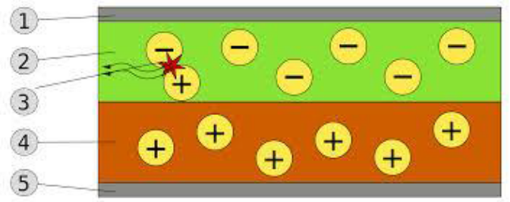BILAYER OLED: 1. CATHODE (-), 2. EMISSIVE LAYER, 3 EMISSION OF RADIATION, 4.CONDUCTIVE LAYER, 5. ANODE (+) [3]

OLED comprises of following components:
1. Substrate- the substrate in an OLED may be a plastic foil or even a glass. If light emitted passes through substrate, such OLED devices are named bottom emission devices.
2. Anode- indium tin oxide (ITO) is the anode component. It is a sufficient conductor having high work function promoting injection of holes into the HOMO levels.
3. Cathode- depending on the type of OLED required, the cathode component is used like barium, calcium and aluminium which have less work function helping injection of electrons into LUMO levels.
4. Electron-transport layer (ETL) - the components used in OLED are PBD, TPBI, Alq3 and BCP.
5. Hole-transport layer (HTL) - The p-type materials for OLED are TPD and NPB.
6. Emissive layer- the emissive layer of an OLED consists of organic plastic molecules like poly-fluorine holes are more mobile than electrons in organic semiconductors. The color of the light produced varies to type of organic molecule used.
In organic electroluminescence, the processes involved are charge injection, charge transportation, exciton formula and light emission [3].

OLED Types:
- Passive matrix OLED (PMOLED):-
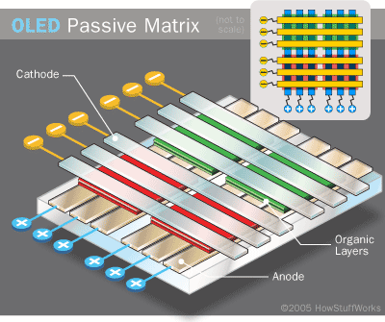

PMOLEDs relates to the way you control the display. A PMOLED display uses a simple control scheme in which you control each row in line in the display sequentially. PMOLED electronics do not contain a storage capacitor and so the pixel in each line is actually off most of the time. To compensate for this you need to use more voltage to make them brighter. For example if we have 10 lines, then you have to make the one line that is on 10 times as bright.
PMOLEDs basically consist of organic layers and anode strips in perpendicular order to the cathode strips. Intersection of strips makes pixels where light is emitted. The brighter the pixel the more amount of current is applied. External circuit provides current to some strips to turn on or off the pixels. They are easy and cheap but use more power than other OLED but still less power than LCD and LED. They are limited in size and resolution. They have wide applications in MP3 player, cell phones displays.

- Active matrix OLED (AMOLED):-
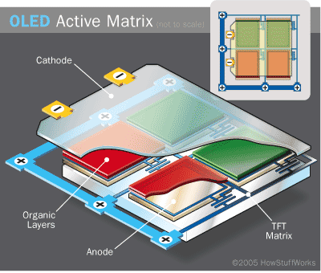
AMOLED refers to the driving electronics, or the TFT layer. When you display an image, you actually displau it line by line (sequentially) as you can only change one line at a time. An AMOLED uses a TFT which contains a storage capacitor which maintains the line pixel states, and so enables large sizes and large resolution displays. AMOLEDs include complete layers of cathode, organic components and anode. The layers of anode consists of TFT (thin film transistors) in parallel to form a matrix, which helps in switching each pixel to it‘s on or off state as required hence, forming an image. When the pixels are not needed, they turn off or a black image on display occurs. This is least power consuming type and has quick refresh rates. They are best used in computer monitors, electronic signs or big TV screens.

- Transparent OLEDs:-
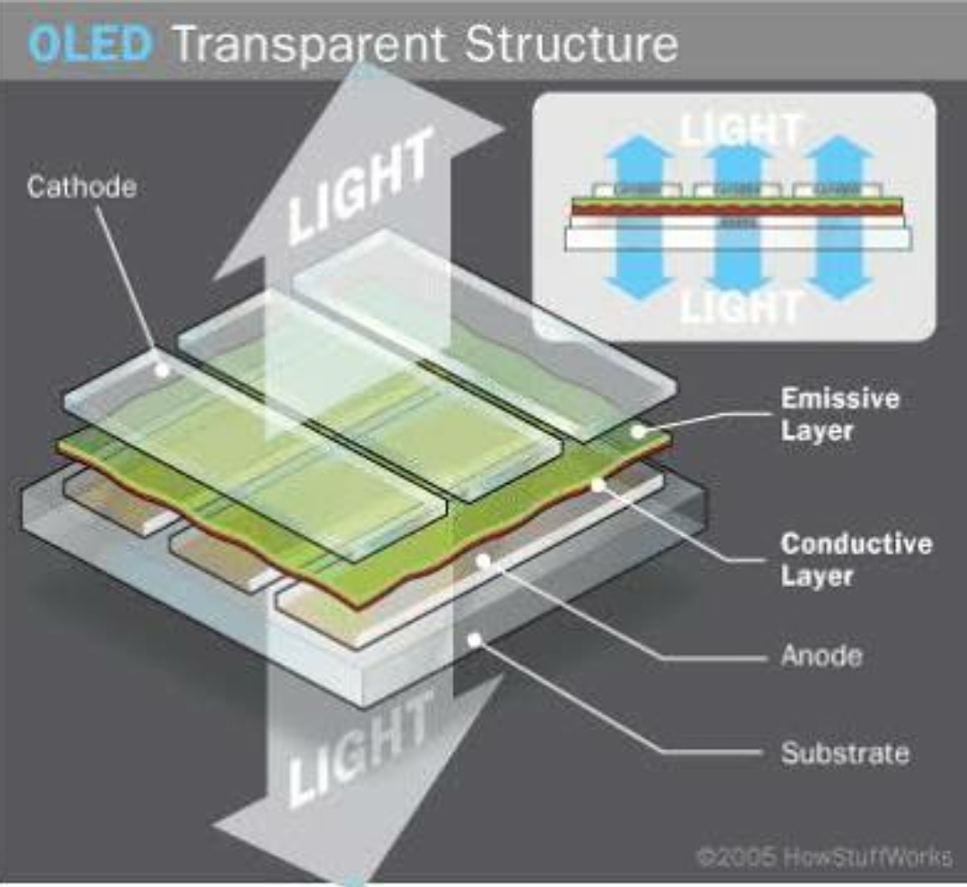

TOLEDs have only components which are transparent as the name suggests like substrate, cathode and anode. When a display of such kind is turned on, light is allowed to pass in both directions. It is applied in both active and passive matrix categories. Since they consist of transparent parameters on both sides, they can form displays with top and bottom emitting. It is widely used in head-up displays, laptops and smart windows. TOLEDs enabled features like transparency, enhanced constant ratio and multi-stacked devices. TOLEDs are applied into a rear-view mirrors and transmitters or had-up information systems.

- Top-emitting OLEDs :-
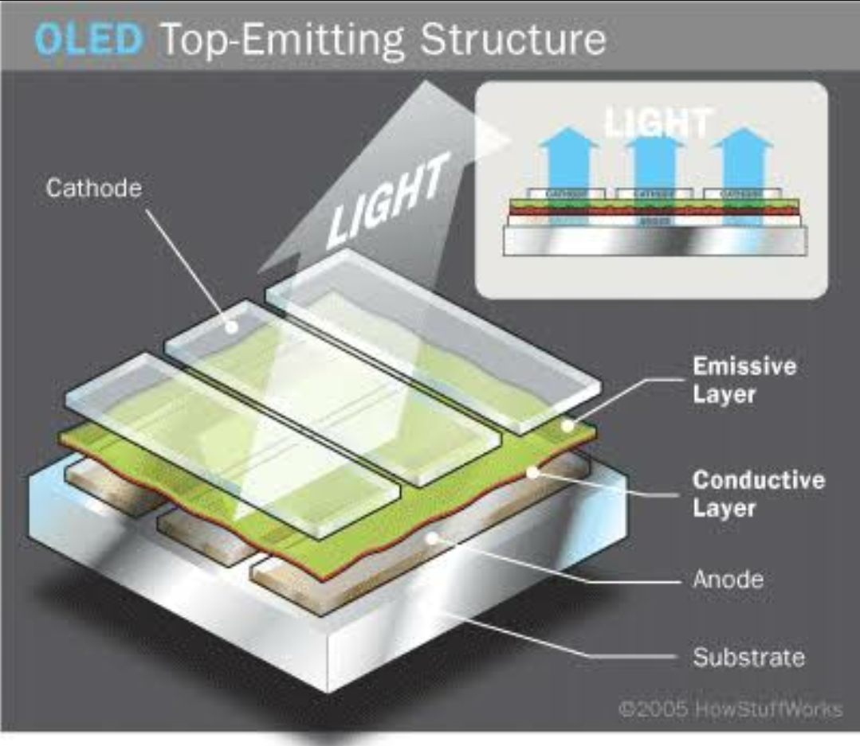
Such OLEDs have either an opaque or reflective substrates. They are preferred for active-matrix applications due to the reason of them being easily integrated with a non-transparent transistor backplane. Top-emitting OLED displays are used by manufacturers in smart cards.

- Foldable OLEDs:-
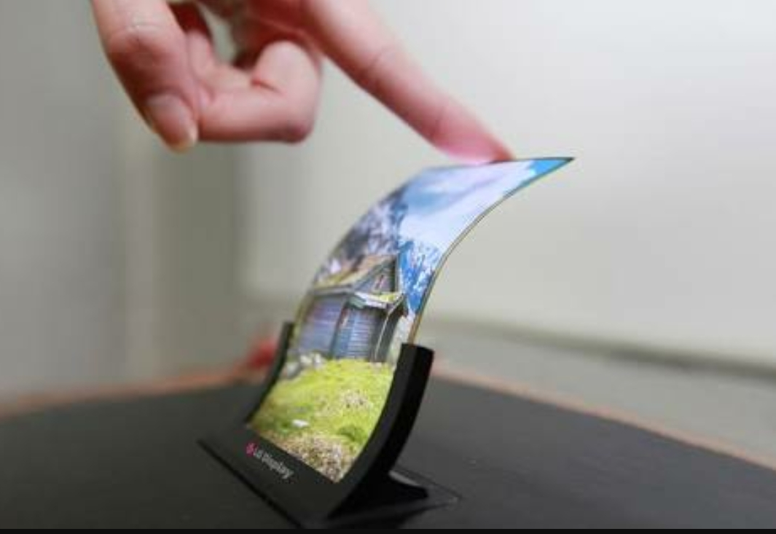
FOLEDs have substrates out of flexible metallic foils of plastics. They have advantages of flexibility, durability and lightweight quality. Since the material has high strength, it decreases breakage and hence, are used in GPS devices, mobile phones and big curved screen TVs. FOLEDs have many added merits like it offers better picture resolution and faster response time. It finds its applications in mobile phones, GPS receiver and OLED display into it.

- White OLEDs: -
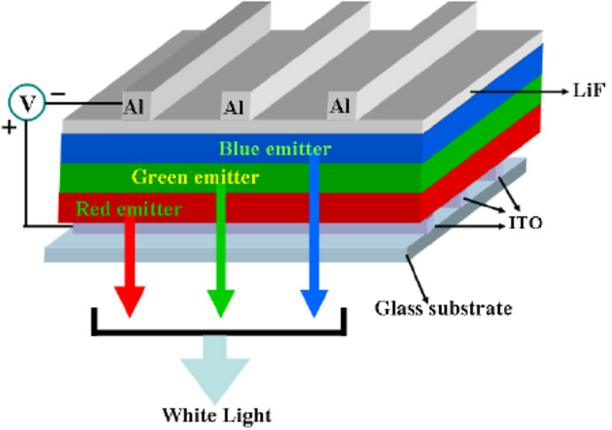
White OLEDs are characterized by true- color qualities of incandescent lightning and emit brighter white light than that by uniform and energy efficient fluorescent lights and incandescent bulbs. Since they are manufactured in big sheets, are cost-effective and consume less power, they replace fluorescent lamps and could decrease energy costs for lightning. It is best suited for car lightning. White OLEDs are thin and light-weight making vehicles more compact and efficient.

- PHOLEDs :-
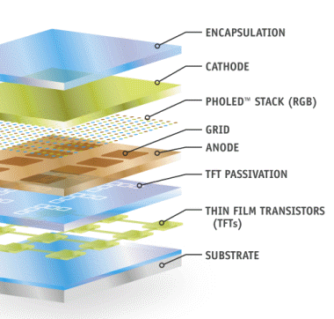
PHOLEDs decreases heat generation. Thus, we find its application in a large-sized OLED TV or lamps. Because it is energy- efficient, PHOLEDs can decrease temperature substantially. It also reduces the quantity of air conditioning needed to remove the produced heat making such a technology a necessary element in ―green or environmental building strategy. PHOLEDs have applications in computer monitors and TV screens or light panels.

Colour Generation
Many attempts have taken place to generate full-colour OLED displays i.e. in fabricating red, blue and green pixels. The complication lies in patterning of pixels and in attaining constantly emitting light in a ratio in correspondence to white colour. But it depends on the intrinsic performance of materials.
Red, green and blue pixels:- The drawbacks include the difficulties of deposition of individual pixels and short lifetime of blue-emitting materials . Yet, they have good optical performances.
Blue emitter and colour converters:- This technique involves only one colour of luminescent material thus, is simple. Blue- emitter structure is first placed over substrate and a red and green colour converter film is then deposited onto the display. Due to losses induced, the blue emitters must have high efficiency, limiting its lifetime .
White emitter and colour filters:- Patterning of pixels is not required. Two or more luminescent materials are used to build white light which turns into red, green and blue because of a colour filter film. Through photolithography techniques, both the colour filters and colour conversion films can be patterned for LCDs. The drawbacks include filtering or efficiency of the colour conversion. At Princeton University, SOLED (stacked OLED) was invented having red, green and blue emitters in each pixel separated by transparent contacts. It has improved resolution. One demerit is brightness reduction[4].

Display Technology
As LCDs are less efficient than OLEDs , this attribute an LCD or OLED display compared with cathode ray tube (CRT) is layout of its active area having pixels forming images in an off or on state. An OLED pixel is an emissive device which can be turned off and be black. A liquid crystal pixel is a Transmissive device not allowing complete occultation of backlight.

1. PASSIVE MATRIX DISPLAYS
A pixel is basically the crossover area of linear electrodes positioned on each side of liquid crystal or of emissive material in OLED. In such case, each line is selected in period of T/N where T is frame time and N is number of lines of display. Then, next line is selected. Slow – Response transducer (LCDs) alters the display contrast and can demonstrate for displays of 100-200lines. Fast-response transducers (OLEDs) can work for display of 240 lines, leading to high power consumption and damage of the pixels. Passive matrix OLED (PMOLED) is attractive due to simple device construction.
2. ACTIVE MATRIX DISPLAYS
In this technique, each pixel is characterized by its own electrode and driven by TFT circuitry and capacitors. The LCD or OLED which acts as an ‗active‘material is deposited on top of active matrix circuitry and the counter electrode which is not patterned. It is used in flat panel displays (FPDs) for large and high-resolution devices[3].

Fabrication
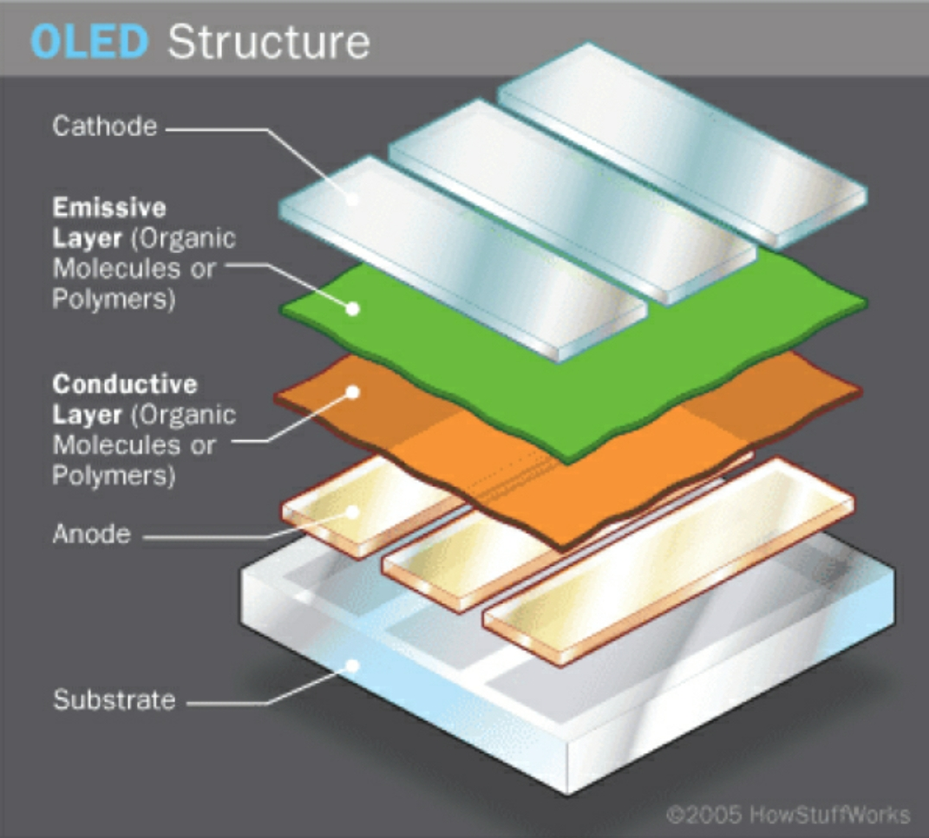
Transfer-printing is an emerging technology to assemble large numbers of parallel OLED and AMOLED devices efficiently. It takes advantage of standard metal deposition, photolithography, and etching to create alignment marks commonly on glass or other device substrates. Thin polymer adhesive layers are applied to enhance resistance to particles and surface defects. Microscale ICs are transfer-printed onto the adhesive surface and then baked to fully cure adhesive layers. An additional photosensitive polymer layer is applied to the substrate to account for the topography caused by the printed ICs, reintroducing a flat surface. Photolithography and etching removes some polymer layers to uncover conductive pads on the ICs. Afterwards, the anode layer is applied to the device backplane to form bottom electrode. OLED layers are applied to the anode layer with conventional vapor deposition, and covered with a conductive metal electrode layer. As of 2011 transfer-printing was capable to print onto target substrates up to 500mm X 400mm. This size limit needs to expand for transfer-become a common process for the fabrication of large OLED/AMOLED displays.

Advantages
Organic materials like OLEDs have wide scope for electronics applications due to many advantages like:-
1. Incorporation of functionality by design – the organic synthetic technology allows infinite flexibility giving molecules packing and macroscopic properties.
2. Very thin solid-state device.
3. Lightweight- the substrates are shatter resistant unlike glass displays of LCD devices.
4. High luminous power efficiency an inactive OLED element does not generate light or consumes power, hence allowing true blacks.
5. Fast response time making entertaining animations- LCDs reach as low as 1ms response time for their fastest colour transition. OLED response times are 1000 times faster than LCD providing 10 microsecond’s response time.
6. Wide-viewing angle- OLEDs enable wider viewing angle in comparison to LCDs because pixels in OLEDs emit light directly. The colours appear correct.
7. Self-emitting hence, removing requirement of a backlight source.
8. Colour tuning for full colour displays
9. Flexibility – OLED displays are fabricated on flexible [117] plastic substrates producing flexible organic LEDs.
10. Cost advantages over inorganic devices- OLEDs are cheaper in comparison to LCD or plasma displays [118].
11. Low power consumption
As OLEDs don’t require backlighting, they consume much less power as compared to LCDs. Production of OLEDs are much simpler than LCDs because they are made up of plastic and hence they can be easily made into large and thin sheets. OLEDs refresh quicker than LCDs hence, video images are more realistic and updated.

Disadvantages
- Lifespan:-
The biggest technical problem for OLEDs was the limited lifetime of the organic materials. One 2008 technical report on an OLED TV panel found that “After 1,000 hours the blue luminance degraded by 12%, the red by 7% and the green by 8%”. In particular, blue OLEDs historically have had a lifetime of around 14,000 hours to half original brightness (five years at 8 hours a day) when used for flat-panel displays. This is lower than the typical lifetime of LCD, LED or PDP technology. Each currently is rated for about 25,000–40,000 hours to half brightness, depending on manufacturer and model. Degradation occurs because of the accumulation of nonradiative recombination centers and luminescence quenchers in the emissive zone.
- Color balance :-
Additionally, as the OLED material used to produce blue light degrades significantly more rapidly than the materials that produce other colors, blue light output will decrease relative to the other colors of light. This variation in the differential color output will change the color balance of the display and is much more noticeable than a decrease in overall luminance.
- Water damage :-
Water can instantly damage the organic materials of the displays. Therefore, improved sealing processes are important for practical manufacturing. Water damage especially may limit the longevity of more flexible displays
- Power consumption
While an OLED will consume around 40% of the power of an LCD displaying an image that is primarily black, for the majority of images it will consume 60–80% of the power of an LCD. However, an OLED can use more than three times as much power to display an image with a white background, such as a document or web site.^{[89]} This can lead to reduced battery life in mobile devices, when white backgrounds are used.

Applications
OLEDs have a wide range of uses which we come across in our daily life. Some important applications od OLEDs are:

- OLED technology is used in commercial applications such as displays for mobile phone and portable digital media players, car radios and digital cameras among others, as well as lighting.
- To build digital displays in TV screens, cell phones, PDAs, monitor.
- OLEDs have wide applications in lighting like Philips made OLED samples with name ‘LUMIBLADE’. Similarly, novaled AG based in germany developed OLED desk lamps named “victory” in 2011.
- In 2014, an OLED panel with life 30000 hours twice that of conventional OLED panels was developed by MCC of the Mitsubishi Chemical Holdings.
- It is used in watches. Fossil (JR-9465) and Diesel (DZ-7086) used OLED displays.
- OLEDs have replaced CRTs (Cathode Ray Tubes) or LCDs (Liquid Crystal Display).
- Samsung electronics generated full-colour AMOLED displays on the basis of a white emitter.
- Top-emission structures have merits for production of OTFT- OLED displays.

- ACKNOWLEDGMENT

How does a person say “thank you” when there are so many people to thank? The person most responsible for this review paper is our Physics Sir Dr. Papanna B Belavi, for his guidance. Thanks to our college KLS GIT, Belgavi to conduct “Avalanche 2017 Fest”.
Lastly I thank God, my Parents and all Teachers.

- CONCLUSION

Since 1990s, the production of OLEDs have been one of the most promising technology due to their advantages over LCDs like high contrast ratio and wide viewing angles like 170 degrees or fast response time. OLED has been hailed as ―the first discovery since Edison‖. Research and development in OLEDs have resulted in future applications like dashboards and in flexible displays. Video images seem more realistic and updated. Yet, it needs to be improved to prevent image sticking. OLED still has many challenges like high production costs, longevity issues for colours or sensitivity to water vapour. In the years 2005 and 2006, the breakthrough of OLED technology in displays had revenue of $832 million and $1.2 billion respectively.

- References

- OLED Wikipedia http://en.m.wikipedia.org.

- A review paper by ‘Fazia Batool’ on “Organic light emitting diode technology and applications”.

- Patent US20060158101- organization “Organic light emitting diode” Application no. US10/547,456

- Organic light emitting diode, Edited by: A Buckley ISBN: 978-0-85709-425-4 www.sciencedirect.com

- OLEDs form http://link.springer.com Reference work done from “Handbook of Visual Display Technology”.

